**Advantages to Compressed Air Pumped Hydropower Storage**

Kaitlyn Loop

The Economics of Oil and Energy

April 7, 2016

**I. Introduction**

Natural gas and coal are cheap, but they are not environmentally friendly. However, not many Americans would want to trade low cost for a source of fuel that is environmentally friendly. So how can we design a form of energy that is clean, but is still as cheap as natural gas and coal? We will never be able to turn our entire energy consumption to one source of fuel, but one solution that can be added to our current sources of energy to help drive down the cost of other renewables, such as a solar and wind power, is the compressed air pumped storage hydropower.

Currently, there are two main sources of hydropower that are used in the United States. These are run-of-river and pumped storage hydropower. Run-of-river generates electricity, whereas pumped storage hydropower stores electricity. These are discussed in more detail in the next section. There are currently 60 licenses for pumped storage hydropower being processed by the United States Government. Instead of building 60 new pumped storage stations, we should build 60 compressed air pumped storage stations. I will discuss how this innovative, new design is cheaper and better for the environment than the pumped storage stations.

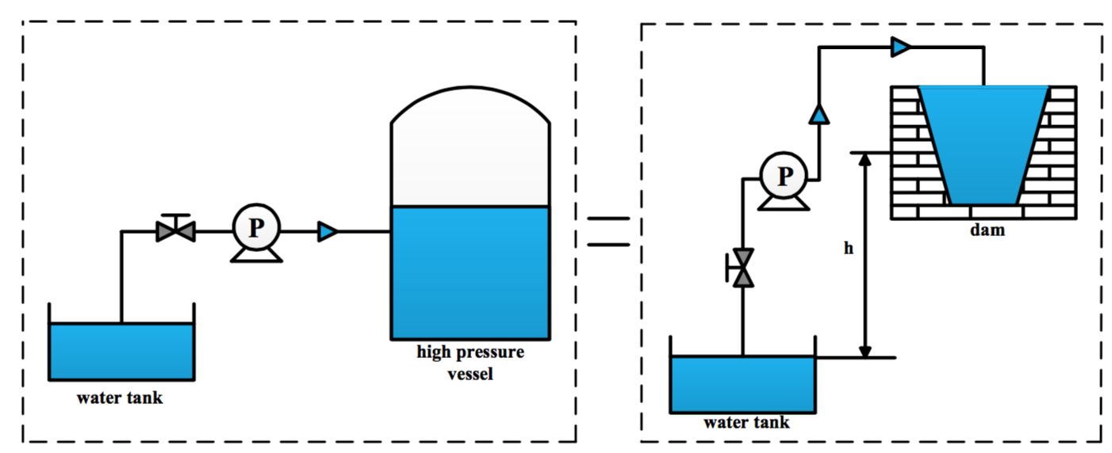**II. Compressed Air Pump Storage**

**Figure 1:** This is a picture of the compressed air pump storage system.[1]

Here I present a simple and short introduction to compressed air hydropower storage. Figure 1 shows a simple design of the compressed air pumped storage system. The picture on the left shows the water tank, a pressure valve, and a high-pressure vessel. Water is pumped in to the high-pressure vessel. As water is pumped in, the pressure in the vessel increases. The increase in pressure creates a “virtual dam.” For example, 5 mega pascals of pressure is equivalent to a dam height of 500 meters. The picture on the right in figure 1 shows the virtual dam.

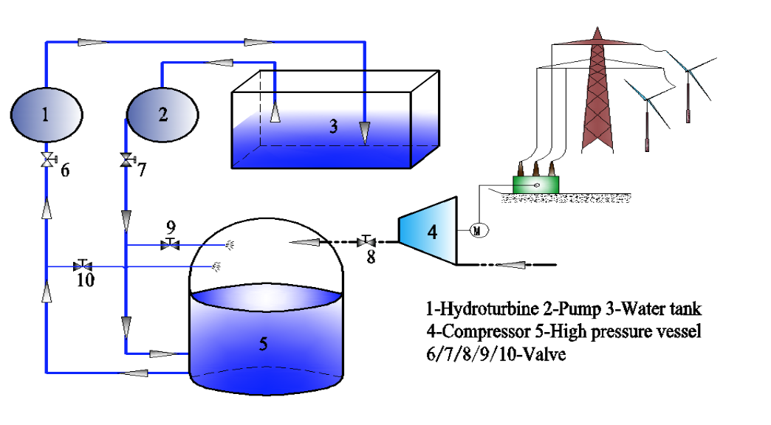

**Figure 2:** This is a picture of a more complex diagram of the compressed air pump system.[2]

Now let’s look at figure 2. This is a more complex image of the compressed air pump system. To start the system, valve 8 is opened. This pumps air into vessel 5 from compressor 4. This creates a pre-set pressure in vessel 5. Then valve 8 is closed. To begin the process of storing the energy, valves 7 and 9 are opened. Using the high-pressure pump 2, the water level in vessel 5 rises, and the air becomes pressurized. The greater pressure in vessel 5 is equivalent to higher elevations in conventional pumped storage systems. This is represented in figure 1 and the previous paragraph’s explanation demonstrating the greater the pressure, the greater the energy output. The air temperature in the vessel increases as more water in pumped in to vessel 5. So to combat this, some water is sent from valve 9 into tank 5 to decrease the temperature. That’s why we opened valve 9 in the beginning. The storage process is done during low demands for electricity. Then valves 7 and 9 are closed, and valves 6 and 10 are opened. The high-pressure water moves the turbine and generates electricity.[3]

**III. Current Types of Hydropower**

Over the years, many types of hydropower plants have been designed. Additionally, many of the types of hydropower plants come in many different sizes. Below I describe some of the advantages and disadvantages of some of the main types of hydropower. Then I will discuss how the new air pressure pumped hydropower station is more economically feasible to add to the current infrastructure.

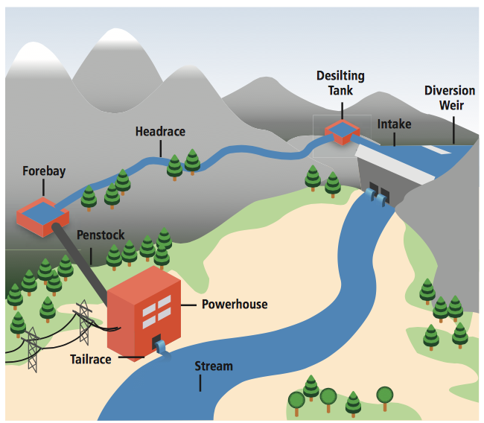**A. Run of River**

**Figure 3:** This is a picture of the run-of- river hydropower system. [4]

One type of hydropower plant is the run-of-river. The run-of-river hydropower systems produce electricity from the natural flow and elevation drop in rivers. Figure 3 is a picture of how a run-of-river hydropower station works. [5]The run-of-river is advantageous because it does not harm the current environment. Another advantage is that the run-of-river stations can be used upon completion of construction. There is no storage unit that needs to be filled. Many sources claim that the run-of-river technology is much cheaper to build compared to pumped storage hydropower, thus reducing the lost of energy; however, this is not true. More on cost will be discussed later.

The run-of-river has many disadvantages. One disadvantage is that energy output is variable between seasons. Depending on the season, more or less energy could be created. Since there is little to no storage in the run-of-river hydropower stations, there are seasons with little electricity production. Sometimes, the demand for electricity does not match the production of electricity because of the variability in flow. Some run-of-river systems contain storage, but the storage only has an hourly or daily capacity.

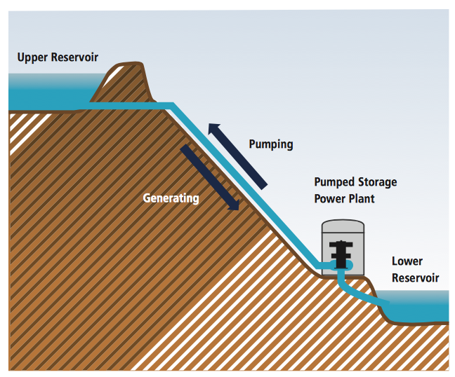**B. Pumped Storage**

**Figure 4:** This is a picture of the

pumped storage hydropower system. [6]

A second type of hydropower plant is pumped storage hydropower. Pumped storage systems use off-peak electricity to pump water from a lower reservoir to a higher reservoir. This is advantageous because electricity can be generated during peak hours and stored during off peak hours. This allows demand to match supply. It also creates stability. Pumped storage systems are like batteries. Pumped storage systems are also able to decrease variability in using other renewable sources, such as wind and solar, because the pumped storage site can produce electricity during the variable and off times of the wind and solar. [7]

Pumped storage hydropower does have some disadvantages. One disadvantage is that when a pumped hydropower station is built, it destroys the environment and the habitats that were previously there. The aquatic ecosystems and terrestrial wildlife habitats are destroyed. Because of this, it is difficult to find locations to build pumped hydropower stations. Another disadvantage is that after the pumped storage hydropower system is constructed, it cannot be used immediately. The upper reservoir must be filled up first. Also, the pumped storage system uses a large plot of land, making the possible number of locations for building these stations scarce. Additionally, the power output of gravity is quite weak compared to other sources of potential energy. To match the energy stored in a single AA battery, we would have to lift 100 kg, 10 meters. To match the energy stored in one gallon of gasoline, we would need to lift 13 tons of water, 1 kilometer high.[8] These calculations clearly show the weakness of gravitational potential. Hydropower makes up for this loss by increasing the volume of the dams. This is a problem too because then the dam takes up more land and destroys even more habitats.

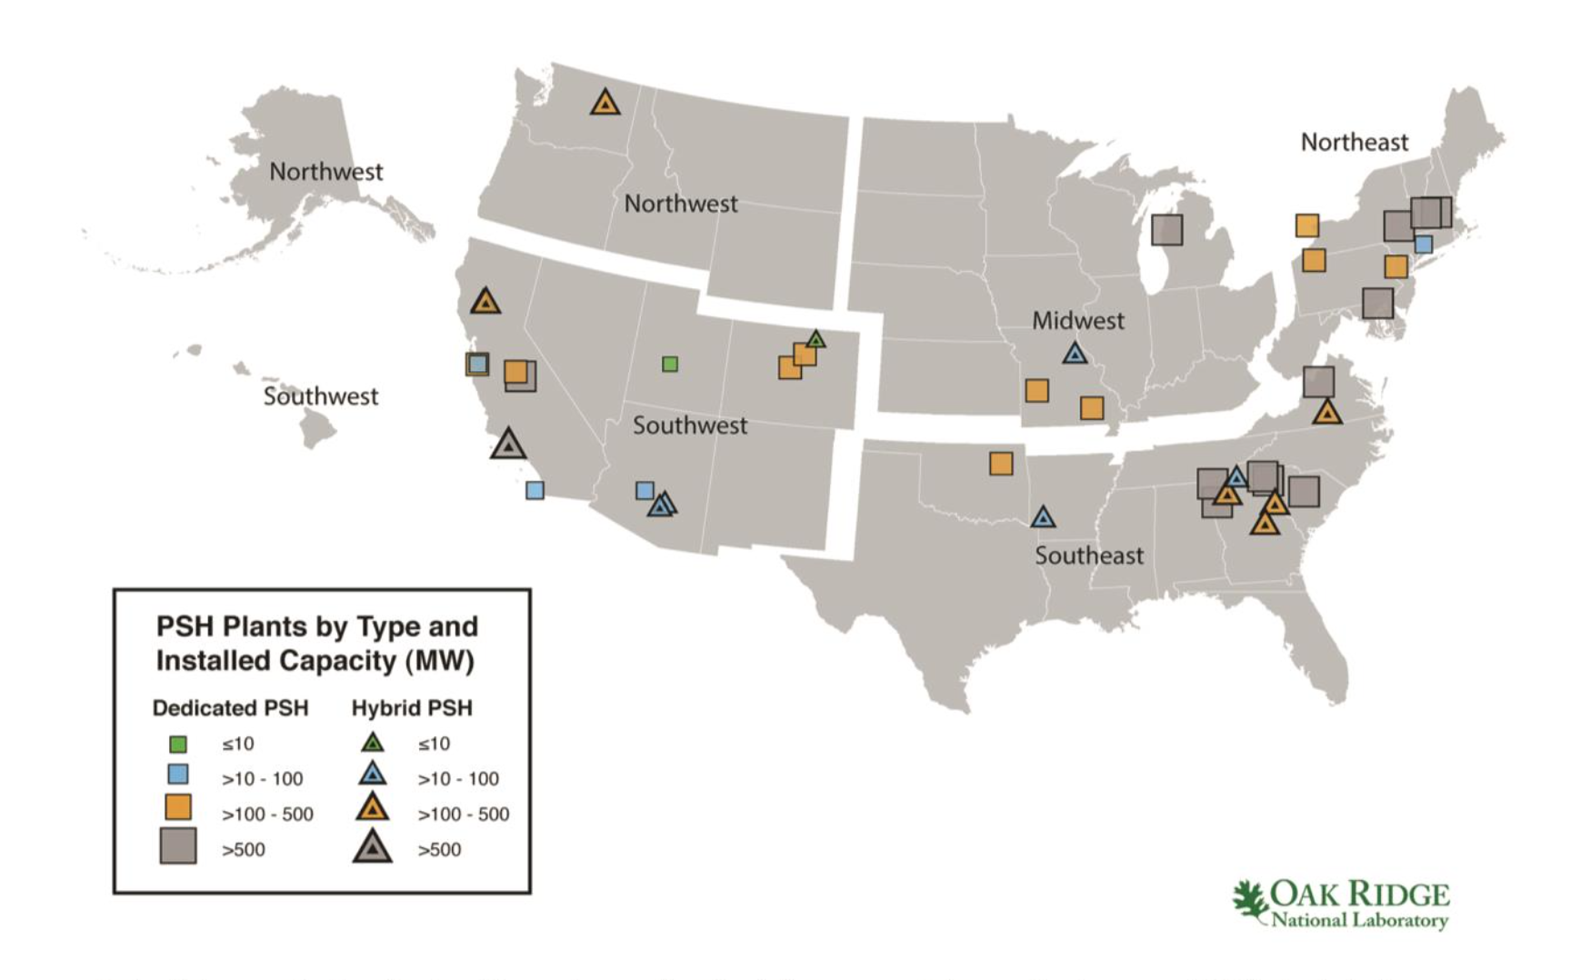

**Figure 5:** This is a picture of the current locations of the pumped storage hydropower plants and their capacity. [9]

Today there are 40 pumped hydropower stations in the United States with 22 gigawatts of storage and 60 getting licenses and permits. The 60 getting licenses have 51 gigawatts of storage.[10] Below is a picture of the current pumped storage hydropower sites in the United States.[11]

**V. Environmental and Economic Advantages to Compressed Air Hydropower**

The compressed air pressure pumped hydropower storage has high reliability, high economic feasibility, and low environmental impact compared to the conventional pumped storage hydropower systems. I will discuss these aspects next.

**A. Environmental**

The compressed air pressure pumped storage facility does not need to be placed on a mountain, near a body of water, or close to a place with lots of rainfall. The only things needed, are a tank of water, air pumps, and a vessel. Theoretically, this could be placed anywhere that there is an empty plot of land. However, I will argue that we should build these next to places with high wind and high solar energy infrastructure. This is because the compressed air system can use the energy produced from the wind and sun to run the pump that pumps the water into the vessel. We currently do not have a way to store the energy produced from wind and solar sources cheaply and this mechanism allows us to.



**Figure 6:** This is a picture of the locations with wind and solar energy present.

Figure 6 shows a map of states with high wind and solar energy infrastructure already in place. [12] From the map, we can see that we should be building compressed air pump storage stations in California, Oregon, Idaho, Wyoming, Colorado, New Mexico, Oklahoma, Kansas, North Dakota, South Dakota, Minnesota, Iowa, and Vermont.

We can also see that there is no carbon dioxide released into the atmosphere from the electricity storage and electricity production. Global warming is a big problem that needs a solution. Using compressed air hydropower stations is a step in the right direction to solve the global warming crisis.

**B. Cost**

Next, it is important to evaluate cost. Everybody’s biggest question for any new technology is how much is this going to cost? Let’s take a look at how much the electricity is going to cost from the compressed air stations. First, I must mention that the stations can produce electricity and store electricity. The produced electricity is not delivered to the power grid, only the stored energy is delivered. This is because the produced electricity, in combination with the solar and wind electricity, is used during demand valleys to store the electricity. The cost of the compressed air hydropower station is tabulated in Haunran Wang’s research paper, A Novel

Pumped Hydro Combined with Compressed Air Energy Storage System. The table is below. [13] The cost is reported in Chinese Dollars. I reproduced the table with the values converted to U.S. dollars.

|  |  |  |  |  |
| --- | --- | --- | --- | --- |
| Type | Equipment | Cost ($) | Cost Fraction | Total Cost |
| Pumped Hydropower Storage | Pump | 18.93 | 6 | 315.32 |
| Hydro Turbine | 37.85 | 12 |
| Compressed Air Hydropower Storage | Compressor | 12.21 | 2 | 260.07 |
| Pump | 18.93 | 2 |
| Hydro Turbine | 37.85 | 2 |
| High Pressure Vessel | 61.05 | 2 |

**Figure 7:** This is a table of how much each part costs for the pumped hydropower storage station and the compressed air pump hydropower storage station. The cost fraction is what we multiply the cost by in the adjacent column to sum up to the total cost.

We can see from the table that it costs $260 per 1 MW of energy storage for compressed air hydropower. This is the capital cost of building the site based off of how much storage it has. This is less than the cost per MW of conventional pumped storage hydropower. The costs of running the machinery to store electricity are not calculated here, but the new technology uses the excess electricity produced from the wind and solar plants, making it practically $0. In the conventional pump, the electricity produced during the day from the system is used to pump the water back up the hill, so the cost here is also practically $0. One last thing to consider is the capacity of the compressed air pump system. It is much more than the conventional pump. The conventional system would require more pumps and more land to produce the equivalent energy of the compressed air pump system making the compressed air pump the cheaper option.

**VI. Conclusion**

Just this week, in both my introductory chemistry course and introductory physics course, my professors talked about how we need to design a way to store energy more effectively. We need something that will not produce greenhouse gases as it stores. We need something that is cheap. We need something that is reliable. We need something that does not impact the environment. We need to find a way to convert between energy forms without losing a lot of energy. From a standpoint of cost and the environment, we can see that the new compressed air pump is a feasible solution to the problem.

Word Count: 2072

1. Wang, Huanran. “A Novel Pumped Hydro Combined with Compressed Air Energy Storage System”
2. Wang, Huanran. “A Novel Pumped Hydro Combined with Compressed Air Energy Storage System”
3. Wang, Huanran. “A Novel Pumped Hydro Combined with Compressed Air Energy Storage System ”
4. Hydropower: http://srren.ipcc-wg3.de/report/IPCC_SRREN_Ch05.pdf
5. International Renewable Energy Agency: http://www.irena.org/documentdownloads/publications/re_technologies_cost_analysis-hydropower.pdf
6. Hydropower: http://srren.ipcc-wg3.de/report/IPCC_SRREN_Ch05.pdf
7. U.S. Department of Energy: Renewable Energy http://www.energy.gov/sites/prod/files/2015/04/f22/2014%20Hydropower%20Market%20Report_20150424.pdf
8. University of California San Diego: http://physics.ucsd.edu/do-the-math/2011/11/pump-up-the-storage/
9. Oak Ridge National Laboratory: http://nhaap.ornl.gov
10. International Renewable Energy Agency: http://www.irena.org/documentdownloads/publications/re_technologies_cost_analysis-hydropower.pdf
11. U.S. Department of Energy: Renewable Energy http://www.energy.gov/sites/prod/files/2015/04/f22/2014%20Hydropower%20Market%20Report_20150424.pdf
12. U.S. Department of Energy: Renewable Energy http://www.energy.gov/sites/prod/files/2015/04/f22/2014%20Hydropower%20Market%20Report_20150424.pdf
13. Wang, Huanran. “A Novel Pumped Hydro Combined with Compressed Air Energy Storage System ”